
RFP-101: OSGi™ Service Platform as a UPnP™ device

Confidential, Draft
17 Pages

Abstract

A local network can contain a number of service platforms. Devices in this network, like appliances, could install bundles in that service platform and provide extra functionalities if they knew the service platform existed. This RFP investigates the requirements that allow these devices to detect the presence of a service platform and manage bundles on that platform.

Document Information

Table of Contents
0 Document Information 2
0.1 Table of Contents 2
0.2 Status 3
0.3 Acknowledgement 3
0.4 Terminology and Document Conventions 3
0.5 Revision History 3
1 Introduction 5
2 Application Domain 6
Entities 6
2.1 6
2.2 Device Control Protocol 7
2.2.1 Complementary technologies 7
2.2.2 OSGi™ UPnP™ Device Service Specification 7
2.3 Security 8
2.3.1 JAVA™ 2 security 8
2.3.2 OSGi™ Service Platform release 4 security 8
2.3.3 OSGi™ RFC 73 Permission Admin with Signature 8
2.3.4 OSGi™ Conditional Permission Admin 8
2.3.5 UPnP™ security 8
3 Problem Description 9
3.1 Proper Application Server Discovery 9
3.2 Device Application Lifecycle Management 10
3.3 Binding a Device Application with Corresponding Application Server Controller 10
3.4 Security Considerations 10
4 USE CASES 12
4.1 Remote Transcoding 12
4.2 Application Installation and Control in Need 12
4.2.1 Discovery of Application Server 12
4.2.2 Lifecycle Management of Device Application 13
4.2.3 Synchronization between Device Application and Connected Device 13
5 Requirements 14
6 Document Support 16
6.1 References 16
6.2 Author’s Address 16
6.3 Acronyms and Abbreviations 17
6.4 End of Document 17

Status
This document suggests the following extension to the OSGi™ Specification. RFP: OSGi™ Service Platform as UPnP™ device for the Open Services Gateway Initiative, and requests discussion. Distribution of this document is unlimited within OSGi™.

Acknowledgement
.

Terminology and Document Conventions
The key words "MUST", "MUST NOT", "REQUIRED", "SHALL", "SHALL NOT", "SHOULD", "SHOULD NOT", "RECOMMENDED", "NOT RECOMMENDED", "MAY" and "OPTIONAL" in this document are to be interpreted as described.
Source code is shown in this typeface.

Revision History
The last named individual in this history is currently responsible for this document.

Revision | Date | Comments
Initial | July 07, 2003 | Initial Draft  SAMSUNG ELECTRONICS CO., LTD jaeleee@samsung.com
2. | Oct. 3, 2003 | Merged proposed RFP 50 with this RFP 49  Peter Kriens, aQute
3. | Jan. 3, 2004 | Updated  SAMSUNG ELECTRONICS CO., LTD jaeleee@samsung.com
4. | Mar. 23, 2004 | Added security related sections on application domains, problem description, user scenarios, and requirements  Hyun-Gyoo Yook (hgyook@samsung.com)  SAMSUNG ELECTRONICS CO., LTD.
5. | Apr. 22, 2004 | Added description on two major user scenarios at Introduction, added three trust model at section Error: Reference source not found, and add two more requirements.  Hyun-Gyoo Yook (hgyook@samsung.com)  SAMSUNG ELECTRONICS CO., LTD.
6 | May 4, 2004 | Changed previous requirements (req-4 ..req-8) to more abstract one (req-4), deleted req-11and req-12 and added a scenario that Device Application could be managed by a management agent as well as its Connected Device.  Hyun-Gyoo Yook (hgyook@samsung.com)  SAMSUNG ELECTRONICS CO., LTD.
7 | May 28, 2004 | Apply Peter’s comments  Hyun-Gyoo Yook (hgyook@samsung.com)  SAMSUNG ELECTRONICS CO., LTD
8 | July 24, 2007 | Modified Document  Kiran Bharadwaj Vedula (Kiran.vedula@samsung.com)  SAMSUNG ELECTRONICS CO., LTD
9 | August 3 , 2007 | Applied Peters Comments  Subramanian k (s.kumar@samsung.com)  SAMSUNG ELECTRONICS CO. LTD
10 | October 5, 2007 | Refined the introduction. Removed a paragraph that was written twice.  Added a section introducing UPnP™ Device Service Specification  Added the new OSGi™ Alliance logo and the trademark  Added UPnP™ and Java™ trademarks.  André Bottaro, France Telecom Group
11 | October 10, 2007 | Modified Document  Updated for Peters comments in section 3.3,  Sreekanth SC (Sreekanth.sc@samsung.com)  SAMSUNG ELECTRONICS CO., LTD

Introduction
Most home devices have severely limited system resources to keep the price as low as possible. That’s why new services for home devices are developed with many restrictions. One of benefits of OSGi™ service platform for device manufacturers is that it offers standard service execution environment for limited home devices. The service application developers for home devices can support significant functionality without unnecessary restrictions in device’s system resources by off loading the execution to the OSGi™ service platform. For example, a video recorder could offload much of the UI control to an OSGi™ gateway while only providing the core functionality in the device itself.
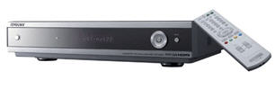


In the current environment where technologies are evolving everyday, home devices are easily out-fashioned due to the limited ability of updating embedded functionalities itself. However, home devices could overcome this problem and have benefits of future-proofness by using an OSGi™ service platform. For example, Tom’s mobile phone has an mp3 song, which is protected by a DRM solution. Tom wants to listen to the song via his living room audio as well. However the living room audio does not support the DRM that the song requires. Tom could enjoy the song via his audio if the audio has OSGi™ service platform, which gets the audio the appropriate environment to play mp3 files, and mobile phone could deploy the DRM solution to the audio..
MP3 File
OSGi™ Framework
DRM Solution
Knows location of
Advertise capabilities
Install DRM solution
Use Audio to listen to song
Delete Application
Audio Device
Mobile Phone

Figure 1: Illustration of Remote Execution
OSGi™ technology provides a service-oriented, component-based environment for developers and offers standardized ways to manage the software lifecycle. These capabilities greatly increase the value of a wide range of computers and devices that use the Java™ platform.
This document describes requirements for new service bundle, SP Exporter that serves bundle lifecycle management functions to an Application Server Controller device.

Application Domain
Figure 2: Entities in the Application Server
UPnP™ CD
Application Server
Service Platform
SP Exporter
Bundle
Device Application
Application Management Service
Connected Device
UPnP™ Service
UPnP™ CP
exposes
Manages lifecycle
Knows location of
has
Controls
Application Server
Application Server Controller

Entities
Application Server | In UPnP™ point of view, it is a UPnP™ Controlled Device that has a UPnP™ Application Management Service. In OSGi™ point of view, it is a service platform that has an OSGi™ SP Exporter bundle.
SP Exporter | An OSGi™ bundle that exposes bundle lifecycle management functions to the UPnP™ world as a UPnP™ Application Management Service.
Application Management Service | A UPnP™ Service that serves functions to manage the lifecycle of OSGi™ bundles. Internally it is the UPnP™ side interface of SP Exporter.
Connected Device | A UPnP™ Control Point device that manages the lifecycle of Device Applications by using a UPnP™ Application Management Service
Device Application | An OSGi™ bundle installed in the Application Server by a Connected Device. It can also be a DP (Deployment Package) as specified in the Deployment Admin Specification.
Application Mapper | Entity which will maintain the relationship between the Application Server Controllers and the Device Applications that the EPCP has installed on to the Application Server.
Execution Handler | The entity responsible for understanding the commands coming from the Application Server controller and sending back the response messages from the OSGi™ to the Controller.
The Application Server Controller and the Application Provider which are given in the dotted lines are out of scope of this specification.

Device Control Protocol

Complementary technologies
In the home network environment, UPnP™ is becoming a de-facto standard protocol for device control in IP based networks. It allows devices to discover each other and to communicate with each other. This RFP assumes UPnP™ as a device discovery and control protocol.
UPnP Device Architecture defines UPnP specific entities: Control points, devices and services. UPnP devices embed UPnP services and other UPnP devices. Thus, service providers are made of devices and services, which are discovered and used by Service Requesters called Control Points.
OSGi™ and UPnP™ are complementary. On the one hand, UPnP™ defines a distributed service-oriented architecture above web-oriented protocols (IP, UDP, TCP, HTTP, XML, SOAP) and IETF standards (SSDP, GENA). UPnP™ technology is a set of protocols and does not target a specific programming language. On the other hand, OSGi™ defines a service-oriented architecture in a component model on a local network node. OSGi™ is a framework taking advantage of the Java™ programming language.

OSGi™ UPnP™ Device Service Specification
The UPnP™ Device Service Specification Error: Reference source not found defines a generic bridge between UPnP™ and OSGi™ technologies represented as a bundle (or a set of bundles) called UPnP™ Base Driver. It provides the developer with an API to implement UPnP™ Control Points as OSGi™ bundles and export OSGi™ services as UPnP™ devices. UPnP™ devices are directly registered as generic UPnPDevice Java™ objects in the OSGi™ service registry and may be discovered like any local OSGi™ service. OSGi™ services also have to be implemented as UPnPDevice objects in order to be exported on the network.
The OSGi™ Device Access specification Error: Reference source not found defines automated mechanisms for device discovery and control. The present RFP relies on these mechanisms while relying on a Discovery Base Driver like the one defined in UPnP™ Device Service specification.

Security

JAVA™ 2 security
Java™ supports following three mechanisms for ensuring safety:
- Language design features e.g. bounds checking on arrays, legal type conversions only, no pointers, and so on.
- Access control mechanism that controls what the code can do such as file access, network access and so on. (Java™ Permissions)
- Code signing, whereby code authors can use standard cryptographic algorithms to authenticate Java™ programming language code. Then, the users of the code can determine exactly who created the code and whether the code has been altered after it was signed.

OSGi™ Service Platform release 4 security
OSGi™ service platform supports an access control capability based on Java™ 2 Permissions. In a platform, a bundle can have a single set of permissions. These permissions are used to verify that a bundle is authorized to execute privileged code. By using Permission Admin and Conditional Permission Admin a Management Agent can administrate the permissions of a specific bundle and provide default permissions for all bundles

OSGi™ RFC 73 Permission Admin with Signature
This RFC proposes a way to do permission administration based on signature. The current OSGi™ Permission Admin allows assignment of permission based on the bundle location. This mechanism has difficulties to manage permissions of a bundle over untrusted channel such as a bundle on a CD or a bundle from ad-hoc network. To solve this problem, the RFC 73 introduces a new class PermissionQualifier to specify bundle location and signers for permission assignment.

OSGi™ Conditional Permission Admin
This specification adds the several new features to the Java™ 2 model to adapt it to the typical use cases of OSGi™ deployments. Permission Management is based on the very general mode of conditional permissions. Conditional permissions match permissions to bundles using OSGi™ Alliance or user-defined conditions. The advantage of this model is that groups of permissions can be shared based on signers and locations. This specification defines a conditional Permission Admin that supersedes the Permission Admin. It provides a security model based on conditional permissions where the conditions define the selection of the bundles that these permissions apply to.

UPnP™ security
UPnP™ security specifications support the following features:
- Mutual authentication between the Application Server and the Application Server Control Point.
- Command authorization for the commands from the Application Server Control Point to the Application Server.
- Message Integrity checks for the command received by the Application Server and the same for the responses back to the Application Server Controller.
- Maintaining session between the Application Server and the Controller.
To support a safe device to device authentication mechanism and access control mechanism, UPnP™ security requires an administrator. An administrator is any device user who knows the shared secret of a security aware device and he takes ownership of the device. After that, the administrator edits access control list of the device, which describes access control policy of the administrator. When a user accesses the security aware device by using an un-allowed security aware control point, the security aware device refuses the access.
USER
Security aware Control Point
Security Aware device
Security Console
Access Control List
Administrator
uses
edits
contains
Takes ownership of
authenticates
uses
Accesses
Figure 3: UPnP™ Security

Problem Description

Proper Application Server Discovery
In order to provide any features of an Application Server device, a device discovery mechanism should be used. Discovery is under the scope of the UPnP™ specifications. UPnP™ follows the SSDP (Simple Service Discovery Protocol) for Device Discovery. The two steps for an Application Server Controller to find a suitable Application Server device and get relevant device capabilities are mentioned below:
- Finding an existent Application Server in the network.
- Getting the capabilities (e.g. available services, packages, auxiliaries …) of the Application Server.

Device Application Lifecycle Management
The Application Server provides an execution environment for Device Applications that are downloaded over a network. Therefore, resource constrained devices (i.e., an Application Server Controller) can use it as an execution environment to process designated Device Application by using the following lifecycle operations.
- Installing Device Applications in the Application Server.
- Starting the installed Device Application.
- Stopping the active Device Application.
- Updating the Device Application when necessary.
- Cleaning up the installed Device Application.

Binding a Device Application with Corresponding Application Server Controller
An installed Device Application could be closely related with a status of its corresponding resource constrained device (i.e., Application Server Controller). In the DRM agent example in the introduction section, the DRM agent program of the mobile phone should not be used by the audio device if the mobile phone is not connected or is turned off.
In this case, the installed Device Application might have following policies
- Stop a Device Application if its Application Server Controllers are plugged out or turned off.
- Start a Device Application if its Application Server Controllers are plugged in or turned on.
- Clean up a Device Application if its Application Server Controller has not been used for a long time. In certain special scenarios (Like EPG) this cleanup can be an optional feature.

Security Considerations
Sometimes, an unknown Application Server Controller tries to install an unknown bundle. The following are threats that could be happen related to the SP Exporter
- A malicious SP Exporter might intercept a Device Application of an Application Server Controller.
- Un-allowed Application Server Controllers might install Device Applications. If we don’t protect this threat, the Application Server could easily become crowded.
- A malicious Device Application, such as virus, might attack the Application Server.
- A malicious Device Application might attack the Application Server Controller.
To protect these threats, it needs to establish following trusts between 3 entities such as the Device Application, Application Server, and the Application Server Controller.
- Trust between Application Server and Application Server Controller: An owner of an Application Server wants to expose the SP Exporter bundle to allow an Application Server Controller to install a Device Application. The owner of the Application Server Controller wants to deliver its Device Application only to a trusted Application Server.
- Trust between Device Application and Application Server: The application provider needs a reliable and trusted platform and the SP Exporter would like to install only applications with some guarantees.
- Trust between Device Application and Application Server Controller: The application should control the device in a correct way, to avoid the risk of damaging it. OSGi™ Exporter or Application Management Service do not involve in this process.
The trusts are established through authentication process. Required authentication information depends on a business model or situation of relevant entities. In case of the Self-Managed Model, the user has confidence of the Application Server Controllers and the Application Server because they are physically present. So a device name or an icon should be sufficient. However in the Service Gateway Model, an operator might require more secure information such as a certificate.

USE CASES

Remote Transcoding
Applications such as transcoding require more CPU usage. So any controller can install such applications on to the Application Server. Controllers can send the data that has to be transcoded to the Application Server and can get the transcoded content back.
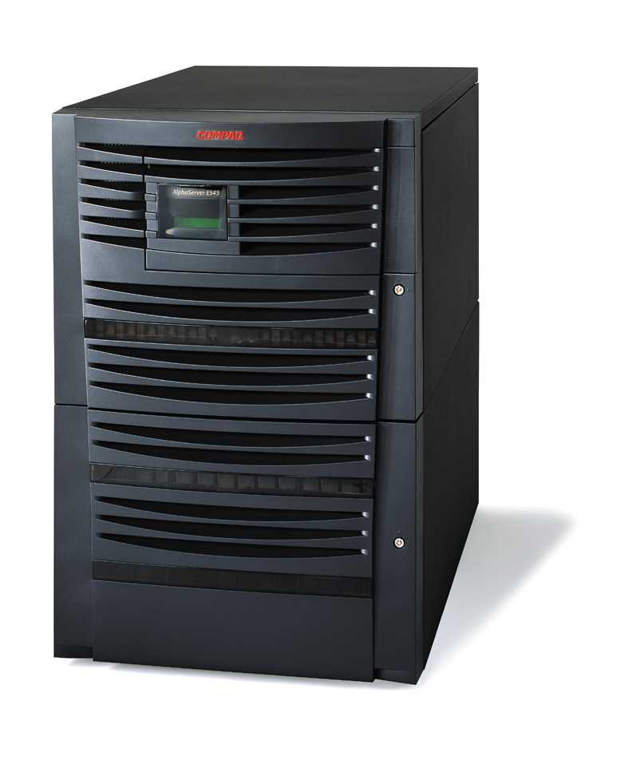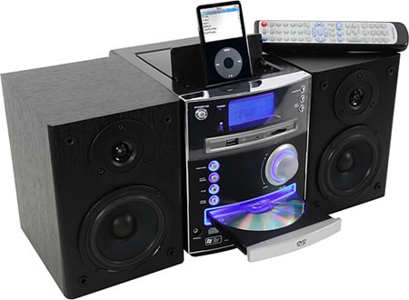
Music System with fewer Resources
Device with Application Server exposed.
Advertise Device
Send Media File (Install)
Transcode Media File
Return Transcoded Media File
Play Transcoded Media
Figure 4: Remote Transcoding

Application Installation and Control in Need
In a scenario where a user has some audio file which is protected by DRM agent. The user wants to listen to the song through his living room audio, which is not having a DRM agent. This is possible if the audio device is having an execution environment. The user can install the DRM agent on to the audio device and can control its lifecycle. After installing the DRM agent the user can transfer his audio content onto the audio device and can enjoy the music through the audio device. A representative diagram for this use case is given in the introduction as Figure 1.

Discovery of Application Server
Tom wants to enjoy the songs via living room audio. When he plugs the mobile phone in the network, the phone finds several Application Servers in the network. The phone retrieves capability of each Application Server such as running services, installed packages and equipped auxiliary devices. Based on the collected information, phone selects the living room audio as the best Application Server.

Lifecycle Management of Device Application
While listening the song, the Tom remembers that a new version of DRM agent is just released. He stops the DRM agent and updates it with a new version by using a mobile phone or by using a management agent of the audio device.

Synchronization between Device Application and Connected Device
Let’s assume the copyright owner has a policy that the song is playable if and only if the mobile phone is connected. So if Tom plugs out the mobile phone, the living room audio needs to stop the DRM agent. And if user plugs in the mobile phone again, the living room audio needs to restart the DRM agent.

Requirements
The OSGi™ SP Exporter or the Application Management Service must provide:
- The ability to announce the OSGi™ service platform’s existence in home network.
The SP Exporter bundle must support the UPnP™ discovery mechanism (SSDP) in order that all home devices can find the Application Server. It must therefore describe itself with UPnP™ templates to devices. The device description of Application Server must include system information and availability of the resources. According to the device description, Connected Devices can decide whether their Device Applications can run on the platform or not.
- Ability to export bundle lifecycle management functions
The Application Management Service must serve the bundle’s lifecycle management functions (Application Management Service) to Connected Devices. Authorized Connected Devices must be able to manage appropriate bundles’ lifecycle residing on an Application Server. Especially, the management service must provide a function of installation of new bundles from the device or from an Internet location. It must also serve functions to start/stop/update and uninstall the installed bundles.
- Ability to check application integrity.
The SP Exporter bundle must check the application’s integrity before installation. It must guarantee that the downloaded application has not been changed after its release.
- Ability to establish trust between Application Server and Connected Device
SP Exporter and Connected Device must have an ability to establish trust between each other. The way to satisfying this requirement could be various depends on business model.
- Ability to bind between the status of a Connected Device and the status of a Device Application that the device installs
In home network environment, a Connected Device might be suddenly turned off without having a chance to stop its Device Application. In this case, the statuses of the Connected Device and the Device Application could be different. To prevent inconsistency between the Connected Device and the Device Application, the SP Exporter must be able to bind the status of the Connected Device to that of the Device Application.
- Ability to set a binding rule
A binding policy depends on Connected Device or operator. So the SP Exporter must be able to set a binding policy by the Connected Device and/or the operator.
- Ability to check availability of executing particular operation
Application Server should be able to check for the availability of executing particular operation. The operations can be not only a service but also a kind of commands, which are executed onto the execution environment.
So, Application can check for the “authorization” on particular command request. Moreover, it can check for the “availability” of designated services.
- Ability to create, update and destroy sessions
Application Server should be able to create sessions before executing any commands from the Application Server Controller. It should also be able to update and destroy the sessions that it has created.
- Ability to check Message Integrity.
The Application Server and Application Server Controller should have the ability to check the integrity of the messages exchanged between them.
- Ability to handle errors
The Application Server and Application Server Controller should be able to handle all the types of errors that may occur during the operation.
- Ability to dispatch events
The Application Server should be able to dispatch the events to Application Server controller asynchronously on receiving events w.r.t bundle state changes and service state changes.

Document Support

References
- UPnP™ Device Architecture http://www.upnp.org/download/UPnPDA10-20000613.htm
- OSGi™ initial provisioning service specification version 1.0
- OSGi™ RFP 73: Permission Admin with Signature
- UPnP™ Security Ceremonies V1.0 http://www.upnp.org/standardizeddcps/security.asp

Author’s Address

Name | Kiran Bharadwaj Vedula
Company | SAMSUNG ELECTRONICS CO,. LTD
Address | Samsung India Software Operations, Bagmane Tech Park, CV Raman Nagar, Bangalore, India
Voice | 91-80-41819999 (6078)
e-mail | kiran.vedula@samsung.com

Name | Jae shin lee
Company | SAMSUNG ELECTRONICS CO,. LTD
Address | Apkujong Bd., 599-4, shinsa-dong, kangnam-gu, Seoul, Korea
Voice | 82-1-3416-0371
e-mail | jaeleee@samsung.com

Name | Peter Kriens
Company | AQute
Address | 34 Place René Nelli
Voice | +33 467871853
e-mail | Peter.Kriens@aQute.se

Name | Hyun-Gyoo Yook
Company | SAMSUNG ELECTRONICS CO,. LTD
Address | Apkujong Bd., 599-4, shinsa-dong, kangnam-gu, Seoul, Korea
Voice | 82-1-3416-0633
e-mail | hgyook@samsung.com

Name | André Bottaro
Company | France Telecom Group – Orange Labs
Address | 28 Chemin du Vieux Chêne, 38243 Meylan Cedex
Voice | +33 476764103
e-mail | andre.bottaro@orange-ftgroup.com

Acronyms and Abbreviations

SP Exporter | Service Platform Exporter
UPnP™ | Universal Plug and Play
UPnP™ CD | UPnP™ Controlled Device
UPnP™ CP | UPnP™ Control Point Device
UPnP™ Stack | The UPnP™ bundle in the OSGi™ framework

End of Document

